New Member Coordinator
Welcome Course Instructions

- Login to my.scouting using or establishing your username and password.
- Click on the BSA Learn Center graphic.
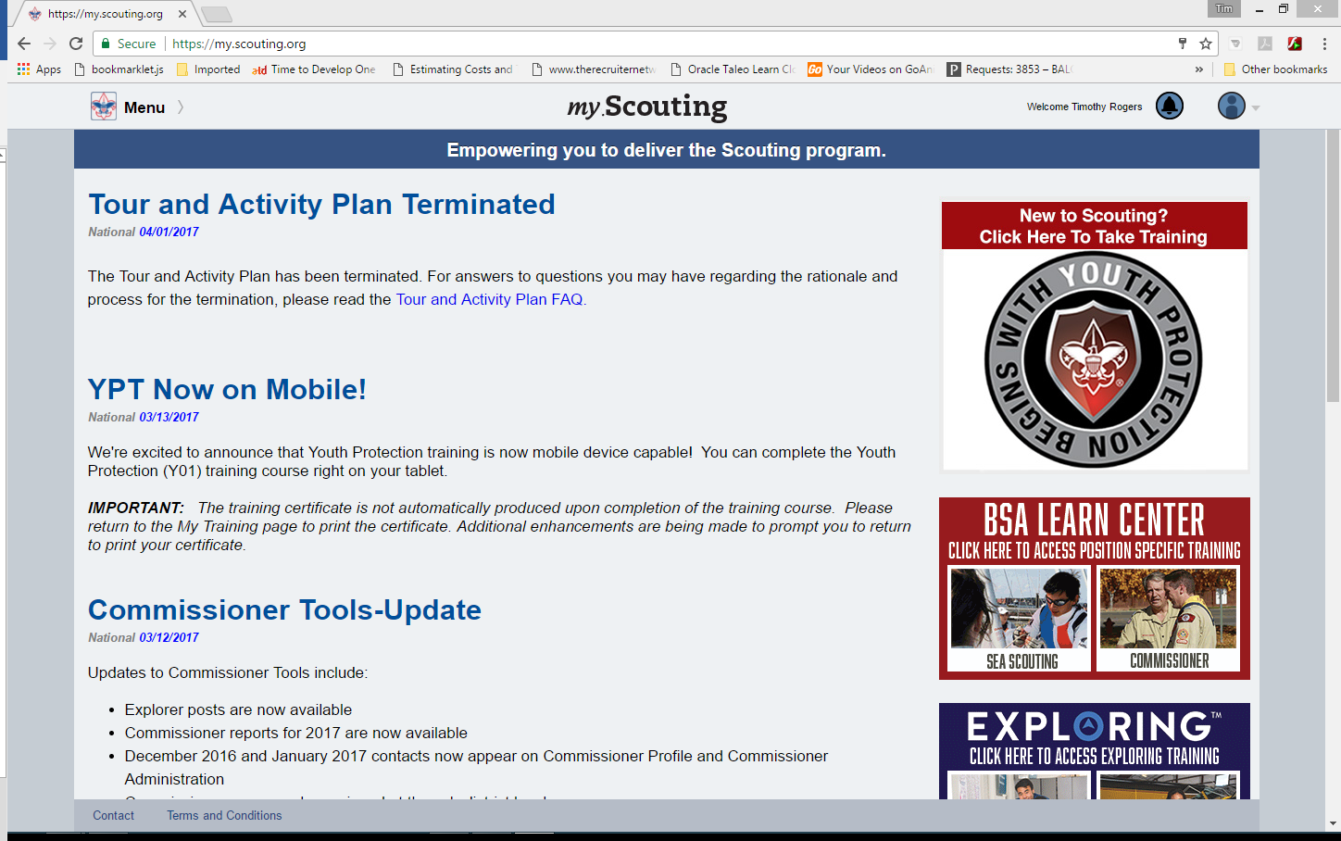
- Click on New Member Coordinator under the Program Specific Training.

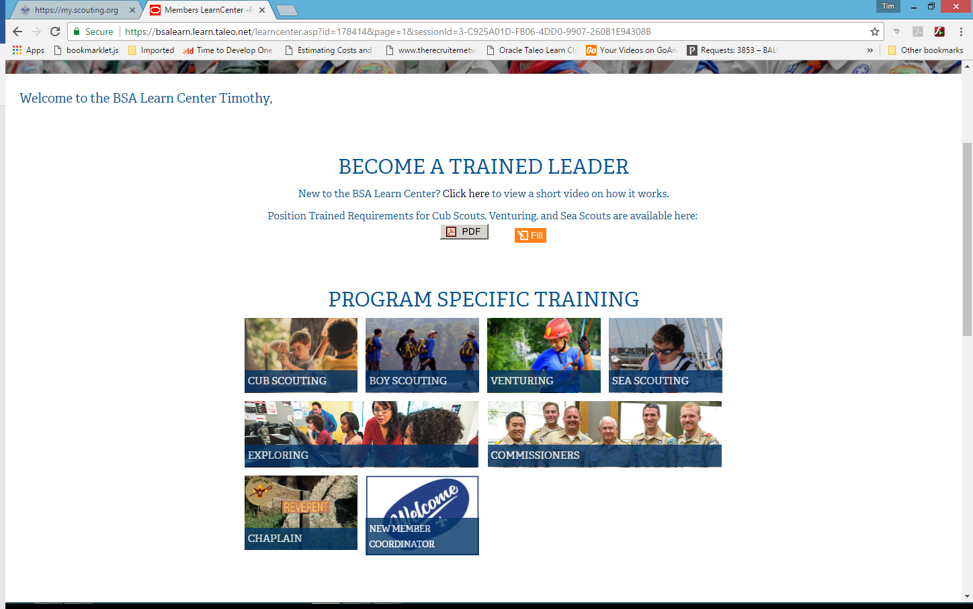
- From this screen click the Add Plan button
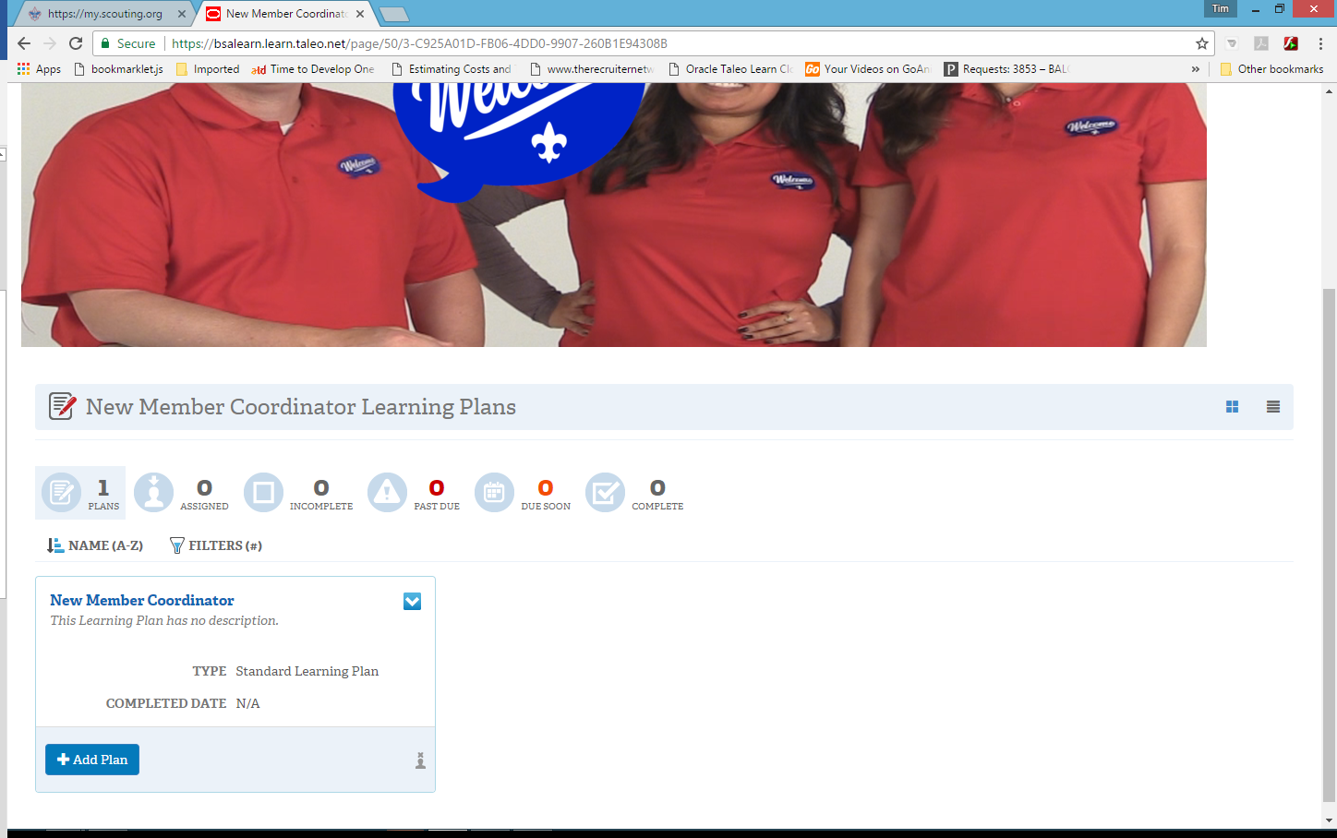
- You will get a confirmation message for the learning plan, click on New Member Coordinator.
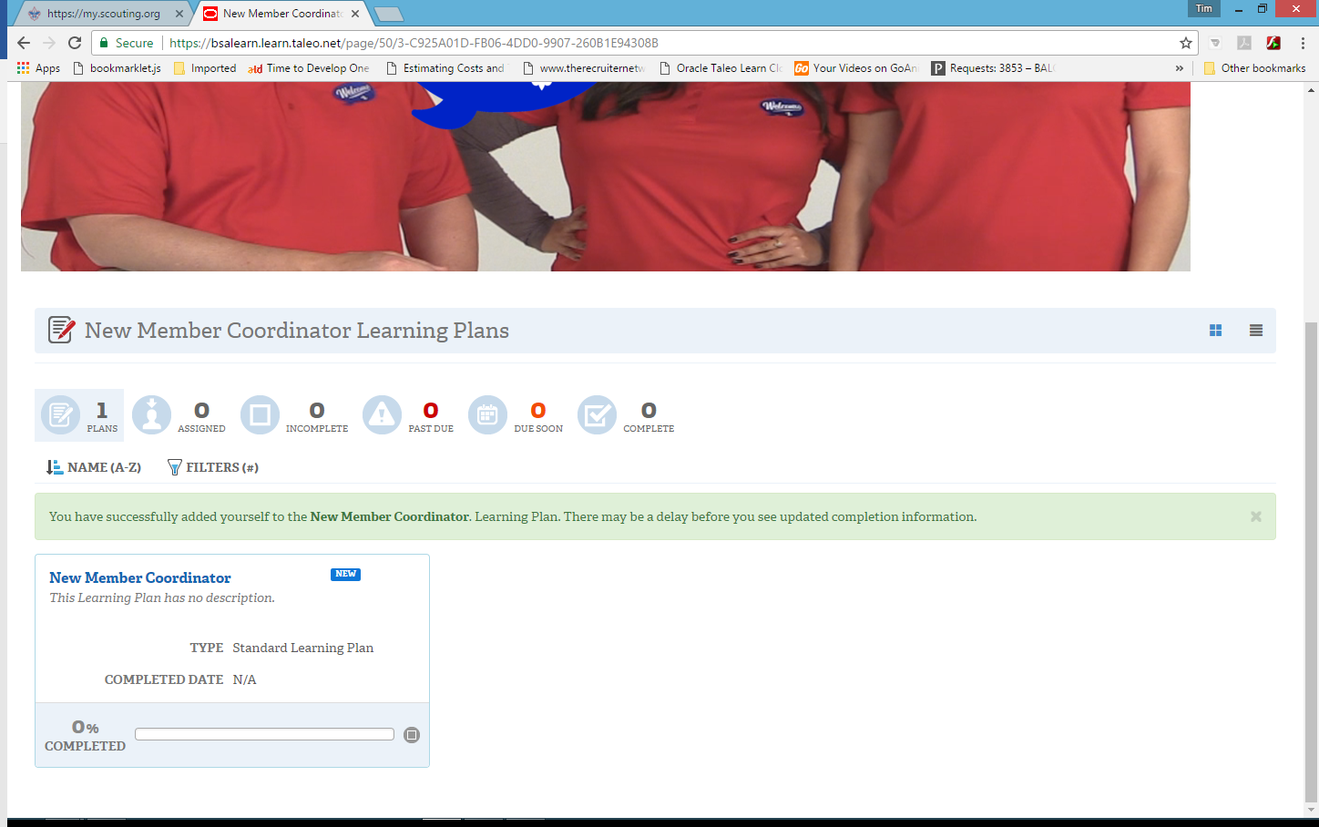

- The Welcome Course will be displayed, click in the course title to access the course.
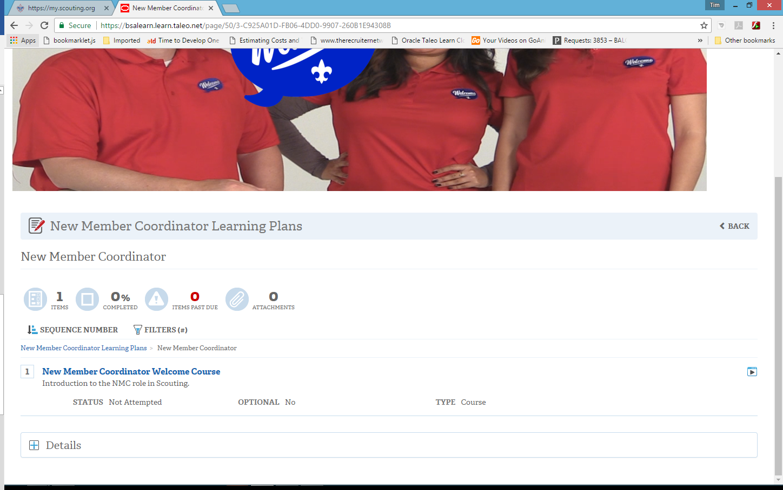
- Click the Open Course button to launch the course.
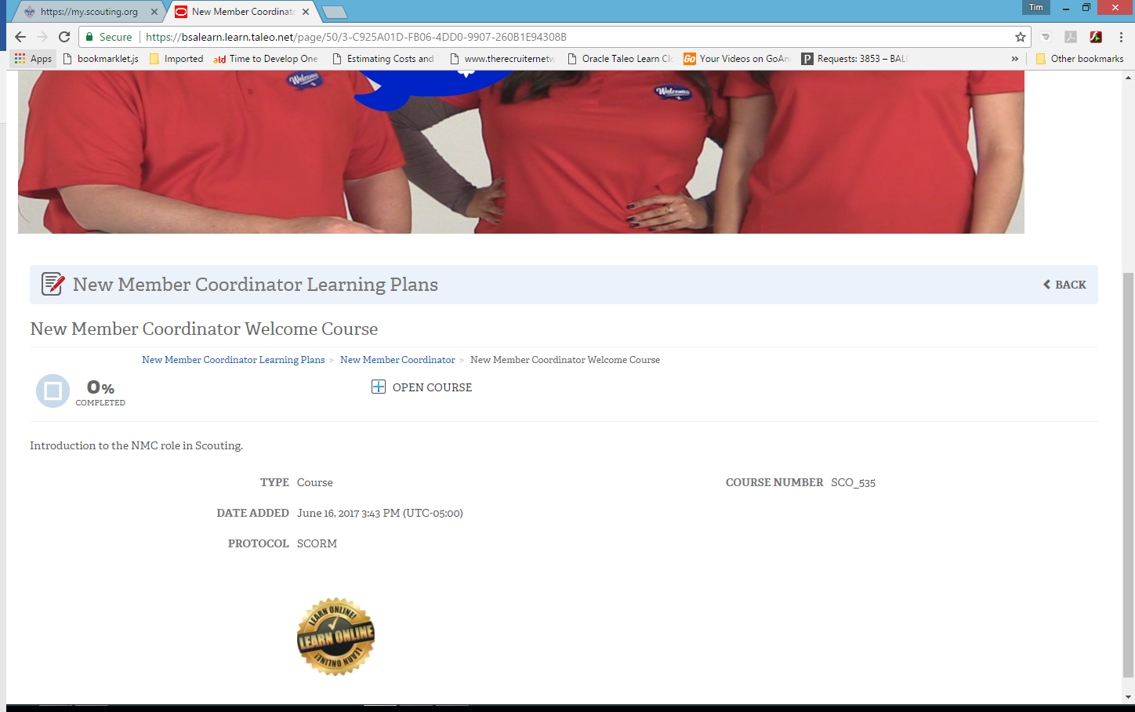

- Complete the course.
