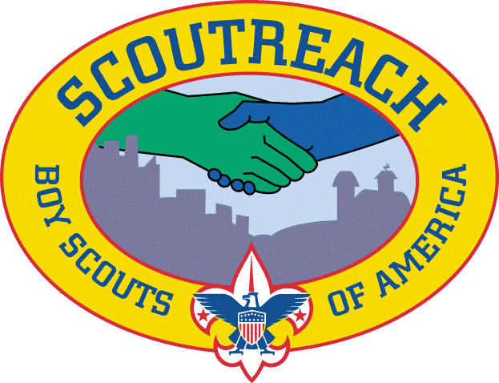

Central Region’s Diversity &
Scoutreach Conference

Hosted by: Michigan Crossroads Council, Great Lakes Field Service Council
Detroit, MI
October 8 – 10th 2019 REGISTER HERE
Topics to be covered include: How to create and sustain quality scouting programs in hard to serve areas. How to provide consistent scouting programs for communities in socio-economic challenged areas. How to diversify your District through community partnerships. Best practices from all over the country.
- Program Delivery
- Funding / Financing your Councils Scoutreach Program
- How to find your community and financial partners.
- Staffing your Scoutreach Programs
The cost of the conference is $65 which includes: 2 lunches, continental breakfast, as well as materials and resources from the conference.
Hotel Accommodations:
A block of rooms have been reserved at The Motor City Casino Hotel $99/Night
Group / Corp Code: 100819RESC
RESERVE YOUR ROOM HERE

